Rate Monotonic

#include <stdio.h>  
#include <stdbool.h>  
#include <math.h>  
#include <stdlib.h>  
  
typedef struct {  
    int id;  
    int execution_time;  
    int period;  
} Task;  
  
  
bool is_rms_schedulable(Task *tasks, int num_tasks) {  
    double cpu_utilization_bound = num_tasks * (pow(2.0, 1.0 / num_tasks) - 1);  
    double total_utilization = 0.0;  
  
    for (int i = 0; i < num_tasks; i++) {  
        if (tasks[i].period <= 0) {  
            printf("Error: Task %d has a non-positive period.\n", tasks[i].id);  
            return false;  
        }  
        total_utilization += (double)tasks[i].execution_time / tasks[i].period;  
    }  
  
    printf("Total CPU Utilization (U): %.4f\n", total_utilization);  
    printf("RMS Schedulability Bound (Ub): %.4f\n", cpu_utilization_bound);  
  
    if (total_utilization <= cpu_utilization_bound) {  
        return true;  
    } else {  
        return false;  
    }  
}  
  
int main() {  
    int num_tasks;  
  
    printf("Enter the number of tasks: ");  
    if (scanf("%d", &num_tasks) != 1 || num_tasks <= 0) {  
        printf("Invalid number of tasks.\n");  
        return 1;  
    }  
  
  
    Task *tasks = (Task *)malloc(num_tasks * sizeof(Task));  
    if (tasks == NULL) {  
        printf("Memory allocation failed.\n");  
        return 1;  
    }

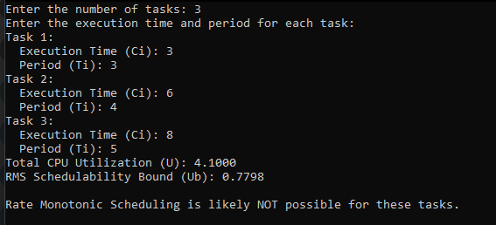

Earliest deadline first

#include <stdio.h>  
#include <stdlib.h>  
#include <unistd.h>  
  
#define MAX_TASKS 10     
  
typedef struct {  
    int id;               
    int execution_time;   
    int deadline;         
} Task;  
  
int compare_deadlines(const void *a, const void *b) {  
    Task *taskA = (Task *)a;  
    Task *taskB = (Task *)b;  
    return taskA->deadline - taskB->deadline;  
}  
  
void edf_schedule(Task tasks[], int n) {  
    int time = 0; // Start time  
  
  
    qsort(tasks, n, sizeof(Task), compare_deadlines);  
  
    printf("\nEarliest Deadline First (EDF) Scheduling:\n");  
  
     
    for (int i = 0; i < n; i++) {  
  
        if (time < tasks[i].deadline) {  
            printf("Time %d: Executing Task %d (Execution Time: %d, Deadline: %d)\n", time, tasks[i].id, tasks[i].execution_time, tasks[i].deadline);  
            time += tasks[i].execution_time; // Increment time by the task's execution time  
        } else {  
            printf("Time %d: Task %d missed its deadline!\n", time, tasks[i].id);  
        }  
    }  
}  
  
int main() {  
    Task tasks[MAX_TASKS];  
    int num_tasks;  
  
  
    printf("Enter the number of tasks (max %d): ", MAX_TASKS);  
    scanf("%d", &num_tasks);  
  
    if (num_tasks <= 0 || num_tasks > MAX_TASKS) {  
        printf("Invalid number of tasks. Please enter a number between 1 and %d.\n", MAX_TASKS);  
        return 1;  
    }  
  
  
    for (int i = 0; i < num_tasks; i++) {  
        printf("\nEnter details for Task %d:\n", i + 1);  
        tasks[i].id = i + 1;  // Assign a unique ID to each task  
        printf("Execution Time: ");  
        scanf("%d", &tasks[i].execution_time);  
        printf("Deadline: ");  
        scanf("%d", &tasks[i].deadline);  
    }  
  
    edf_schedule(tasks, num_tasks);  
  
    return 0;  
}

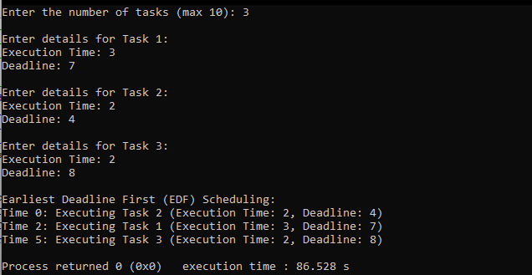

Producer and consumer

#include <stdio.h>  
#include <pthread.h>  
#include <semaphore.h>  
#include <stdlib.h>  
#include <unistd.h>  
  
#define BUFFER_SIZE 5  
#define MAX_ITEMS 10 // Maximum items to be produced and consumed  
  
int buffer[BUFFER_SIZE];  
int in = 0, out = 0;  
  
sem_t empty, full;  
pthread_mutex_t mutex;  
  
void* producer(void* arg) {  
    for (int i = 0; i < MAX_ITEMS; i++) {  
        int item = rand() % 100;  // Produce an item  
        sem_wait(&empty);         // Wait for an empty space in the buffer  
        pthread_mutex_lock(&mutex); // Critical section  
  
        buffer[in] = item;  
        printf("Produced: %d\n", item);  
        in = (in + 1) % BUFFER_SIZE;  
  
        pthread_mutex_unlock(&mutex); // Exit critical section  
        sem_post(&full);             // Signal that buffer is full for consumer  
  
        sleep(1); // Sleep to simulate production time  
    }  
    return NULL;  
}  
  
void* consumer(void* arg) {  
    for (int i = 0; i < MAX_ITEMS; i++) {  
        sem_wait(&full);           // Wait for a filled space in the buffer  
        pthread_mutex_lock(&mutex); // Critical section  
  
        int item = buffer[out];  
        printf("Consumed: %d\n", item);  
        out = (out + 1) % BUFFER_SIZE;  
  
        pthread_mutex_unlock(&mutex); // Exit critical section  
        sem_post(&empty);            // Signal that buffer has empty space for producer  
  
        sleep(1); // Sleep to simulate consumption time  
    }  
    return NULL;  
}  
  
int main() {  
    pthread_t prod_thread, cons_thread;  
  
    // Initialize the semaphores  
    sem_init(&empty, 0, BUFFER_SIZE); // Initially, the buffer is empty  
    sem_init(&full, 0, 0);            // Initially, no items are in the buffer  
    pthread_mutex_init(&mutex, NULL);  
  
    // Create the producer and consumer threads  
    pthread_create(&prod_thread, NULL, producer, NULL);  
    pthread_create(&cons_thread, NULL, consumer, NULL);  
  
    // Wait for the threads to finish  
    pthread_join(prod_thread, NULL);  
    pthread_join(cons_thread, NULL);  
  
    // Destroy the semaphores and mutex  
    sem_destroy(&empty);  
    sem_destroy(&full);  
    pthread_mutex_destroy(&mutex);  
  
    return 0;  
}

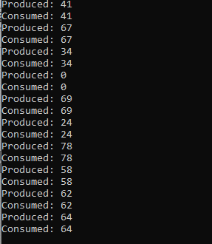

Dining Philosopher

#include <stdio.h>  
#include <pthread.h>  
#include <semaphore.h>  
#include <unistd.h>  
  
#define NUM_PHILOSOPHERS 5  
  
sem_t chopsticks[NUM_PHILOSOPHERS];  
  
void* philosopher(void* num) {  
    int phil = *(int*)num;  
  
    printf("Philosopher %d is thinking.\n", phil);  
    sleep(1);  // Simulate thinking time  
  
    printf("Philosopher %d is hungry.\n", phil);  
  
    // Pick up left chopstick (phil)  
    sem_wait(&chopsticks[phil]);  
  
    // Pick up right chopstick (phil + 1)  
    sem_wait(&chopsticks[(phil + 1) % NUM_PHILOSOPHERS]);  
  
    // Eating  
    printf("Philosopher %d is eating.\n", phil);  
    sleep(2);  // Simulate eating time  
  
    // Put down right chopstick (phil + 1)  
    sem_post(&chopsticks[(phil + 1) % NUM_PHILOSOPHERS]);  
  
    // Put down left chopstick (phil)  
    sem_post(&chopsticks[phil]);  
  
    printf("Philosopher %d finished eating.\n", phil);  
  
    return NULL;  
}  
  
int main() {  
    pthread_t threads[NUM_PHILOSOPHERS];  
    int phil_num[NUM_PHILOSOPHERS];  
  
    // Initialize the chopsticks (semaphores)  
    for (int i = 0; i < NUM_PHILOSOPHERS; i++) {  
        sem_init(&chopsticks[i], 0, 1);  // Each chopstick is available (value = 1)  
    }  
  
    // Create philosopher threads, but only run one or two philosophers  
    for (int i = 0; i < 2; i++) {  // Limit to the first 2 philosophers for output  
        phil_num[i] = i;  
        pthread_create(&threads[i], NULL, philosopher, &phil_num[i]);  
    }  
  
    // Wait for the philosophers to finish  
    for (int i = 0; i < 2; i++) {  // Wait only for the first 2 philosophers  
        pthread_join(threads[i], NULL);  
    }  
  
    // Destroy the semaphores  
    for (int i = 0; i < NUM_PHILOSOPHERS; i++) {  
        sem_destroy(&chopsticks[i]);  
    }  
  
    return 0;  
}

